13.2 Dyke
The total length of the dyke including the intertidal regions is about 60.13 km. The total length of dyke is divided into three zones based on the bathymetry and soil profile in the project area. The three zones are (i) Intertidal zone at Bhavnagar, (ii) Gulf region and (iii) Intertidal zone at Dahej.

13.2.1 Bathymetry
The length of the intertidal zone at Bhavnagar is 19.83 km and the sea bed level in this zone is around +4.0 m to 4.5m MSL. The gulf region is about 26.7 km with a maximum depth of (-)27 m below MSL consisting predominantly of silty sand. The length of intertidal zone at Dahej is 13.60 km and the sea bed level in this region is +3.0 to +5.0 m MSL. Figure 13.2.1 shows the bathymetry and geotechnical profile of the dyke. Table 13.2.1 provides the length corresponding to different water depths. There are three intermediate submerged islands that are located in between the gulf region that range from (-)5 to (-)15 m w.r.t. MSL.

Table 13.2.1 Length for different water depths
Water Depth w.r.t MSL | Length in km
> + 5 m | 12.9
+ 5 m to 0 m | 15.7
0 m to (-) 5m | 5.1
(-)5 m to (-)10m | 5.4
(-)10m to (-)15 m | 7.8
(-) 15 m to (-) 20 m | 7.6
(-)20 m to (-) 25 m | 4.7
< (-) 25 m | 1.0

13.2.2 Geotechnical Parameters

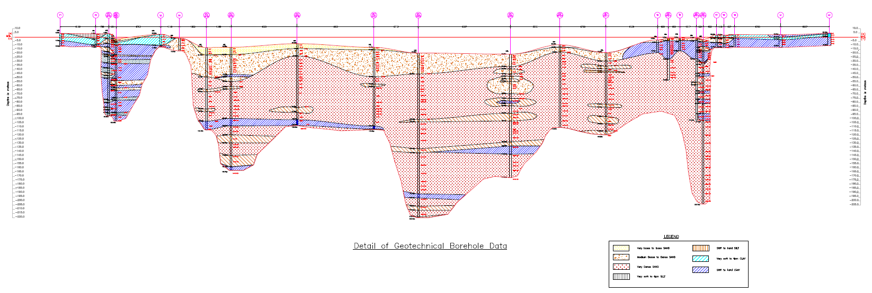
Figure 13.2.1 : Geotechnical Profile of the dyke
All the present analyses are performed based on the Borehole data and corresponding cross sections shown in Table 15.3. The detailed soil profile has been provided in Chapter 10. The plastic stress-strain analysis, stability/safety, strength, and dynamic and seepage analyses are carried out for eight different cross sections of the dyke in the gulf and intertidal region. The dyke sections are 7 m, 16.5 m, 24 m, 29 m, 34 m, 39 m, 44 m, and 49 m high, and the corresponding reduced levels of the sea bed are +5 m, 0 m, (-)5 m, (-)10 m, (-)15 m, (-)20 m, (-)25 m, and (-)30 m. The critical boreholes considered for the analyses are listed in table 13.2.2.
Table 13.2.2 Zones along the Dyke alignment and corresponding Dyke cross sections
Zone | BH no. | Corresponding Dyke cross section w.r.t MSL
Gulf | GT/SPT 7 | -5 m, -10 m, -15 m, -20 m, -25 m, -30 m
Bhavnagar | GT/SPT 2 | -5 m, 0 m, +5
Bhavnagar | GT/SPT 3 | -5 m, 0 m, +5
Dahej | GT/SPT 12 | -5 m, 0 m, +5
Dahej | GT/SPT 13 | -5 m, 0 m, +5

Table 13.2.3 Material parameters of dyke elements used in FE modelling
Parameter | Dredged sand | Gabion mat | ACCROPODE II
Material model | Mohr-Coulomb |  | Linear Elastic
Drainage type | Drained
Unsaturated unit weight, $γ_{unsat}$ (kN/m³) | 16 | 18 | 20
Saturated unit weight,$γ_{sat}$ (kN/m³) | 20 | 21 | 20
Elastic Modulus, $E$ (MPa) | 32 | 1000 | 100
Poisson Ratio, $ν$ | 0.33 | 0.2 | 0.2
Cohesion, $c$ (kN/m²) | 1 | 1
Friction angle $ϕ$ (degrees) | 35 | 45
Dilatancy angle $ψ$ (degrees) | 0 | 15
Coefficient of permeability, $K_{x}=K_{y}=K_{z}$ (m/day) | 13 | 86 x 10³ | 86 x 10³

Table 13.2.4 Material parameters of various stones used in FE modelling
Parameter | 10-500 kg | 300-500 kg | 500-1000 kg | 2-4 T | 8-10 T | Riprap
Material model | Mohr-Coulomb
Drainage Type | Drained
Unsaturated unit weight, $γ_{unsat}$ (kN/m³) | 18 | 18 | 18 | 18 | 18 | 18
Saturated unit weight,$γ_{sat}$ (kN/m³) | 21 | 21 | 21 | 21 | 21 | 21
Elastic Modulus, $E$ (MPa) | 1000 | 1000 | 1000 | 1000 | 1000 | 1000
Poisson Ratio, $ν$ | 0.2 | 0.2 | 0.2 | 0.2 | 0.2 | 0.2
Cohesion, $c$ (kN/m²) | 1 | 1 | 1 | 1 | 1 | 1
Friction angle $ϕ$ (degrees) | 45 | 45 | 45 | 45 | 45 | 45
Dilatancy angle $ψ$ (degrees) | 15 | 15 | 15 | 15 | 15 | 15
Coefficient of permeability, $K_{x}=K_{y}=K_{z}$ (m/day) | 43 x 10³ | 70 x 10³ | 70 x 10³ | 86 x 10³ | 86 x 10³ | 43 x 10³

The geotechnical properties of the different dyke elements and the material model used for various elements are presented in Table 13.2.3 and Table 13.2.4. As the material properties and flow parameters are not available for the dyke, the values are assumed based on the multidisciplinary project report on breakwater engineering by Delft University of Technology, 2015, Durban Dig-Out Port Research.

13.2.3 Overall Geometry
(a) Breakwater
The sea water level post-construction of dyke is estimated to be +6.2m MSL corresponding to Highest Astronomical Tide (HAT) and (-)5.3 m MSL corresponding to Lowest Low Tide Level (LLTL). The significant wave height in the location is estimated to be 8.1m and the design water level is estimated to be 8.1m w.r.t. MSL. The dyke section on seaside is designed as breakwater using desk and wave flume studies.

The crest level of the breakwater is designed based on the allowable overtopping rate for safety and structural design as per the guidelines provided in Coastal Engineering Manual (CEM) and finalized by wave flume studies. The overall design is based on the desk and wave flume studies carried out by CWPRS. The typical cross section of the dyke is given in Figure 13.2.3.

The crest level for sections at seabed levels of (-) 5.0 m seabed and below is +19.0 m MSL. The crest levels in the shallow regions with seabed bed level at 0 m, +2.0 m and +5.0 m are +16.5 m, +15.0 m and +12.0 m respectively. The crest levels of the breakwater in intertidal zones will be gradually reduced to connect the existing roads at Bhavnagar and Dahej, which is at +10.0 m level. The breakwater consists of armour layer (primary layer), secondary layer, core and toe berm.

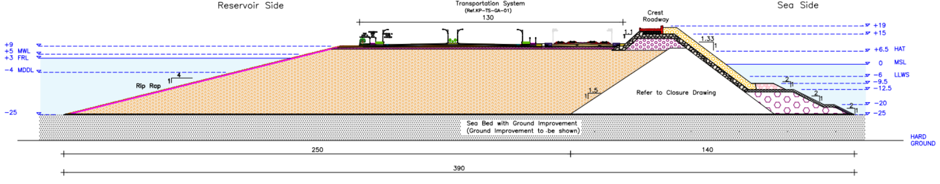
Figure 13.2.2: Cross section of the Dyke

(b) Embankment
The placement of the transportation corridor on the dyke is based on the storm surge and Seiches study carried out by IIT Delhi. The results indicate that there will be an increase in water level by 2.5m during a hypothetical cyclone track. Therefore, the transportation corridor is located on the crest of sand fill embankment on the reservoir side at an elevation of +9.0 m MSL elevation (4m above MWL). The sand fill embankment on the reservoir side is protected by providing the riprap protection and filter layer.
Based on stability studies, a slope of 1: is adopted on the reservoir side for the sandfill. The slope of the rockfill on the reservoir side is also slightly modified to 1:1.1 slope, in order to reduce the rock fill material used in the dyke. The dredged fill used as the base for the entire stretch for the heavy vehicles and trains was also replaced with 1 m thick rock fill at the base of the pavement for proper distribution of load onto the embankment.

(c) Graded Filter
A designed inverse rock filter needs to be constructed between rock fill and dredged sand embankment. The functions of this filter are to protect the sand content in the embankment and also not to allow the escape of it into rock fill and thereby into the sea. These layers are to be placed after completing the breakwater. The thickness of these layers and the sizes of the rock to be employed are dependent on the design. However, the construction method of placement of these layers needs to be decided after forming the expert group and taking the inputs from them.

(d) Bed Protection
To prevent the seabed from erosion and increase the lateral stability of the dyke, a floor protector needs to be constructed after improving the ground. A polypropylene mattress can be laid on the top of the compacted soil over which varied thickness of quarry stone can be placed as per scour analysis.

